Course Name:  Course Code: | Digital Logic Design Laboratory (DLDL)  316U06L202 | Semester: | II
Date of Performance: | 18 / 03 /2026 | Batch No: | A1
Student Name: | Arav Arun | Roll No: | 16010125013
Faculty Sign & Date: |  | Grade/Marks: | / 2
Experiment No: 9
Title: Design of Synchronous Counter using MSI IC
Aim and Objective of the Experiment:
Design and verify the 4-Bit Synchronous Counter IC. Design and implement sequential logic circuits and their applications

COs to be achieved:
CO4: Implement sequential logic circuits and applications using MSI devices.
CO5: Understand basic principles required for advanced Digital Design

Pin Diagram: 4-bit synchronous counter IC 74161
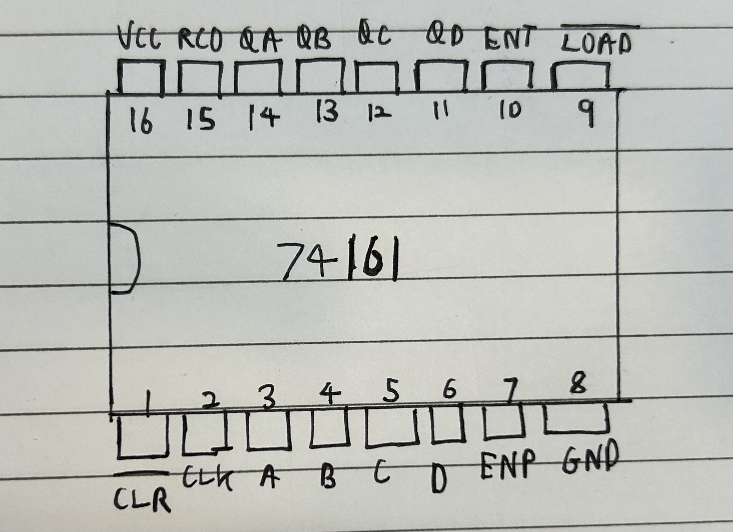

Logic Diagram: 4-bit synchronous counter
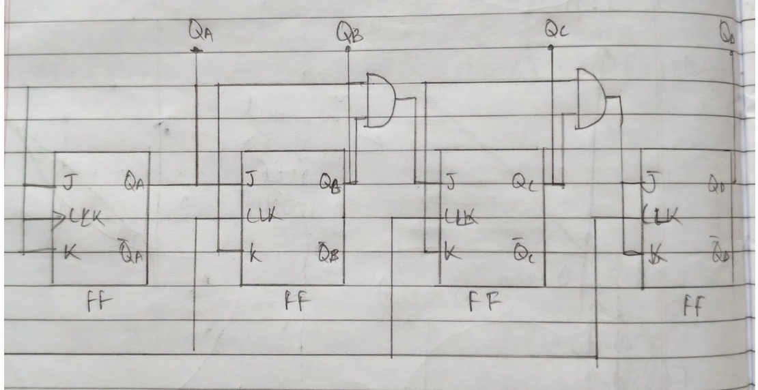

Truth Table: 4 bit synchronous Counter
Clock State | Outputs
S | Q3 | Q2 | Q1 | Q0
0 | 0 | 0 | 0 | 0
1 | 0 | 0 | 0 | 1
2 | 0 | 0 | 1 | 0
3 | 0 | 0 | 1 | 1
4 | 0 | 1 | 0 | 0
5 | 0 | 1 | 0 | 1
6 | 0 | 1 | 1 | 0
7 | 0 | 1 | 1 | 1
8 | 1 | 0 | 0 | 0
0 | 1 | 0 | 0 | 1
10 | 1 | 0 | 1 | 0
11 | 1 | 0 | 1 | 1
12 | 1 | 1 | 0 | 0
13 | 1 | 1 | 0 | 1
14 | 1 | 1 | 1 | 0
15 | 1 | 1 | 1 | 1
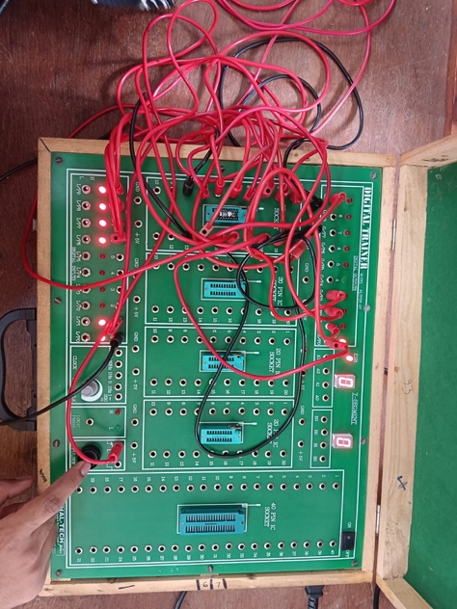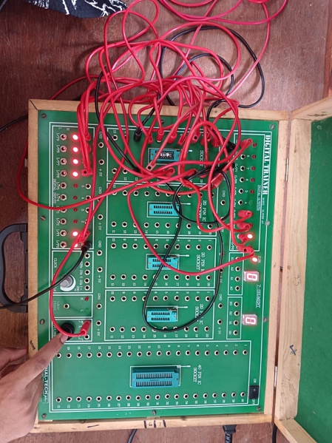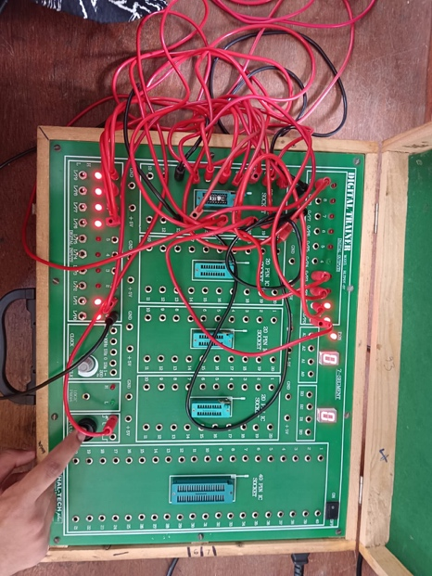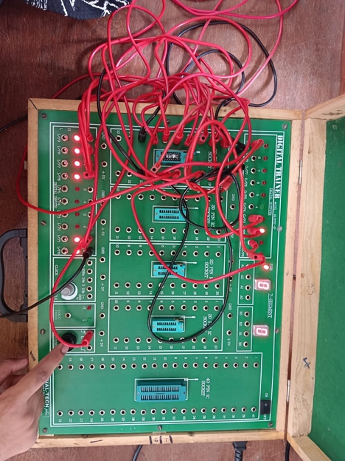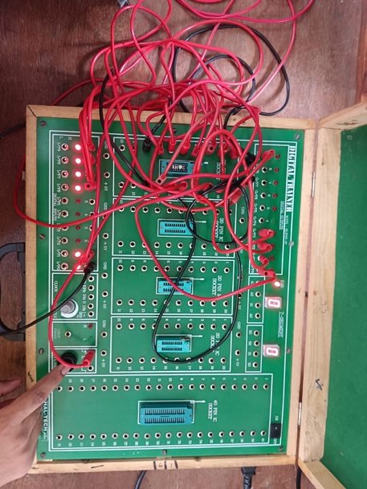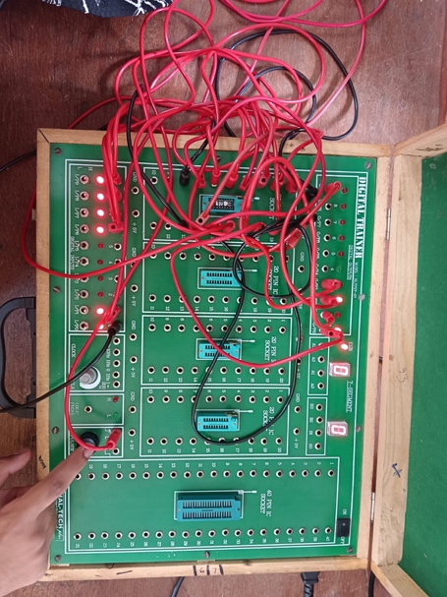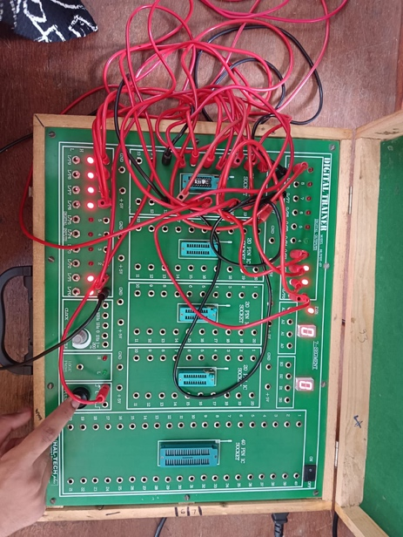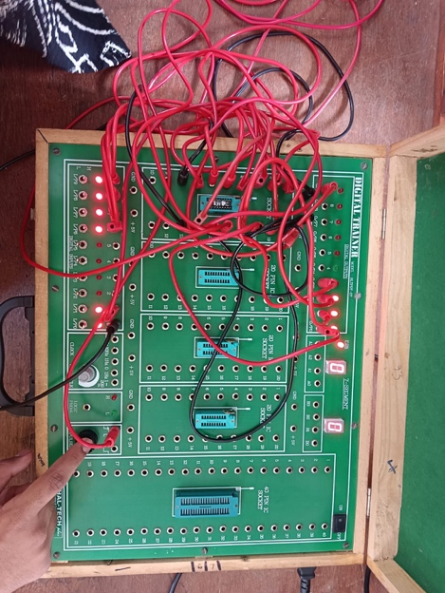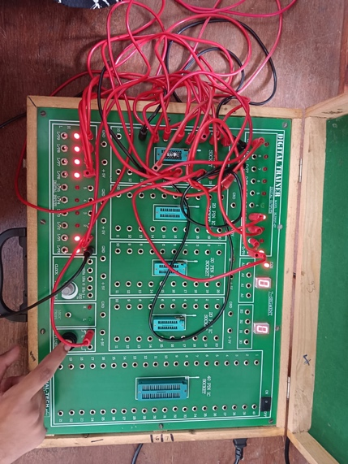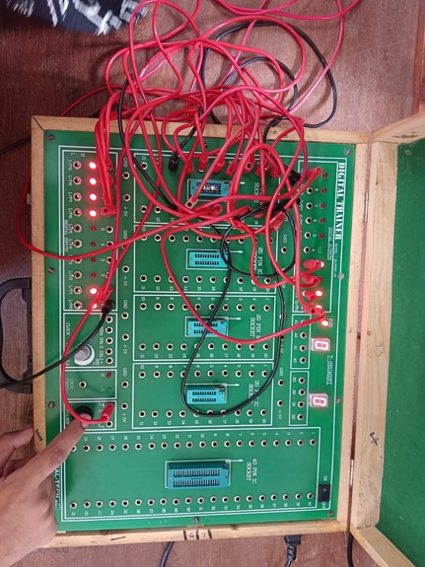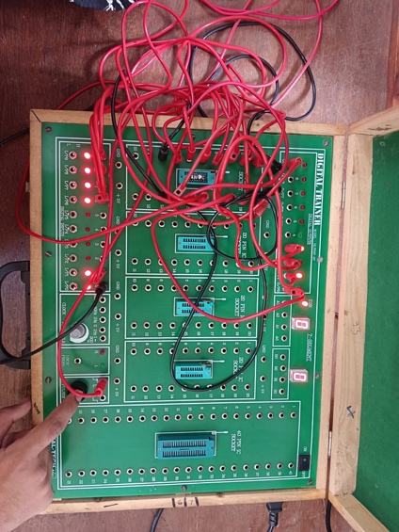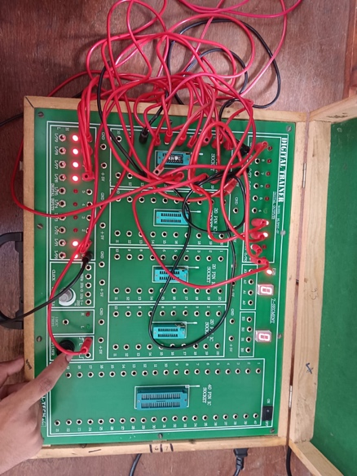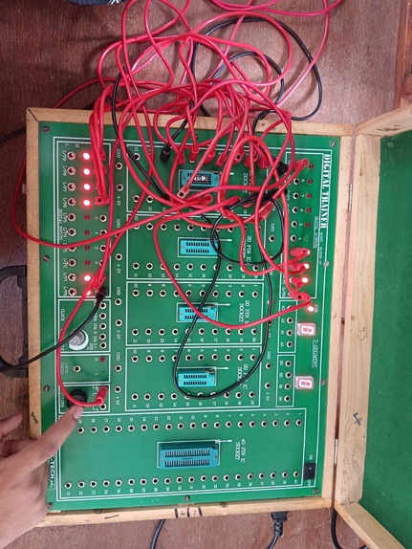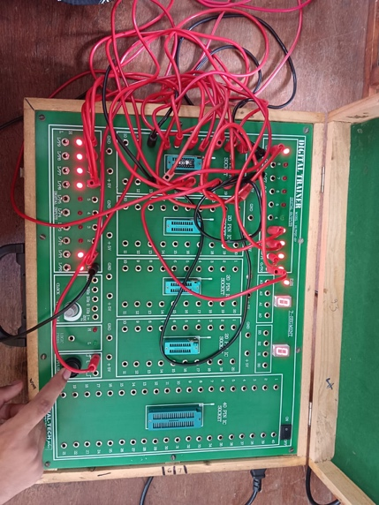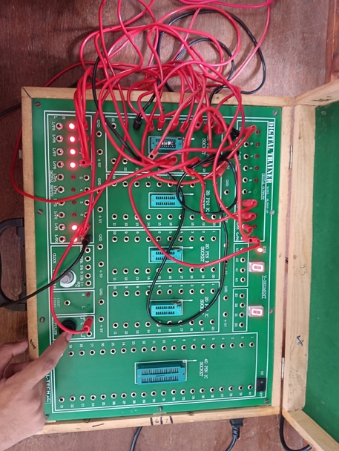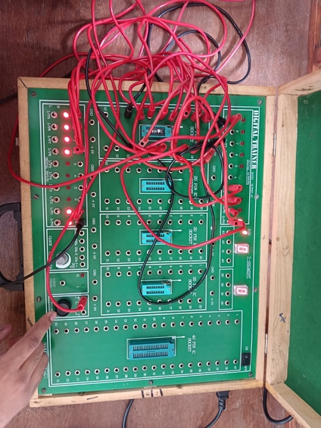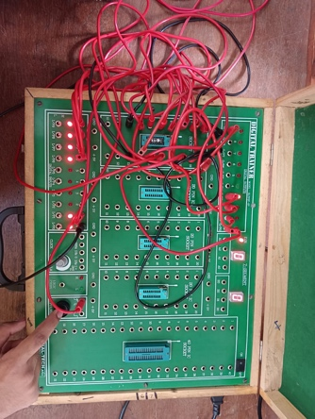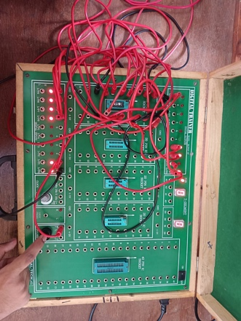
Conclusion:
The 4-bit synchronous counter was successfully designed and verified using flip-flops and logic gates. All outputs changed simultaneously with the clock pulse, confirming proper synchronous operation. The circuit followed the expected counting sequence from 0 to 15. This experiment helped in understanding the design and implementation of sequential logic circuits. Such counters are widely used in digital systems like timers, frequency dividers, and control applications.

Signature of faculty in-charge with Date:

